**Lab 5**

Q1:  




compress command deletes the original file and replaces it with the compressed file with extension .Z.

uncompress returns the compressed file to the original file and the compressed file deleted.





gzip command replaces the original file with the compressed file with extension .gz.

gunzip returns the compressed file to the original file and the compressed file deleted.

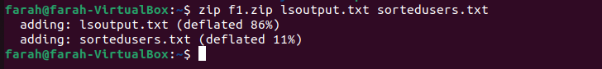

zip command compresses multiple files into a single archive file.

zip command adds the .zip extension to the file name of the compressed archive file if you do not assign a new file name with an extension.

Compress will run faster and use less memory, but gzip will generally reach significantly higher levels of compression.

Q2:

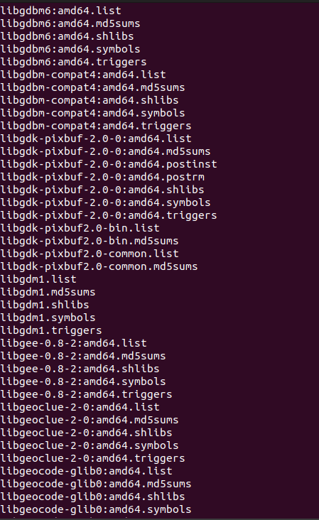

It displays content of compressed file without uncompress it.

Q3:  
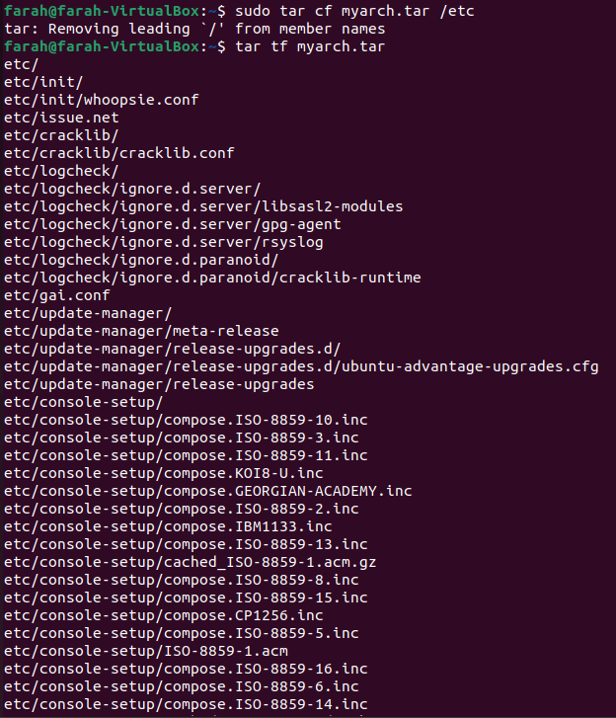

Q4:  
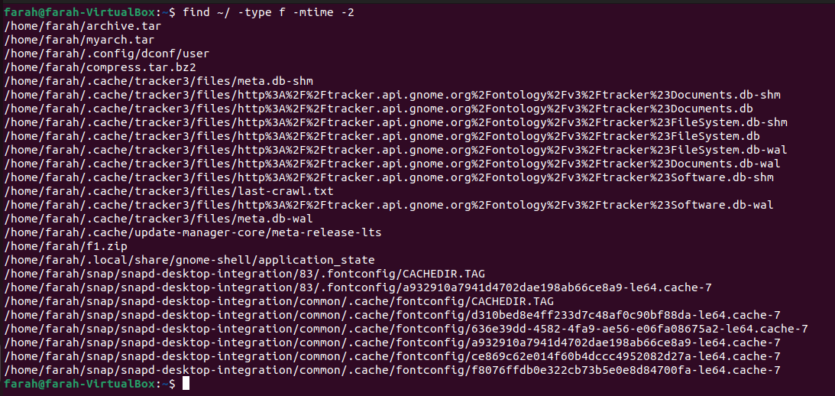

Q5:  
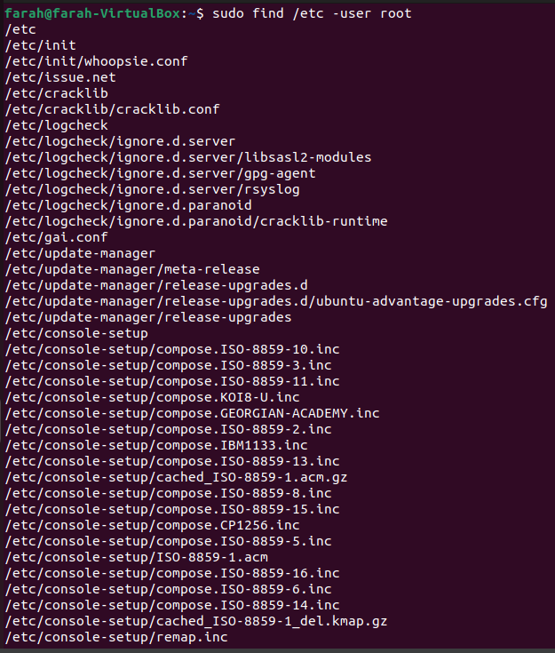

Q6:

Q7:  
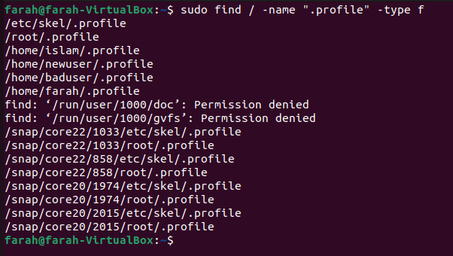

Q8:

Q9:

Q10:

diff command --> If there are no differences, there will be no output. If there are differences, diff will display the lines that differ.

cmp command --> If the files are identical, there will be no output. If there are differences, cmp will indicate where the first difference occurs.

Q11:

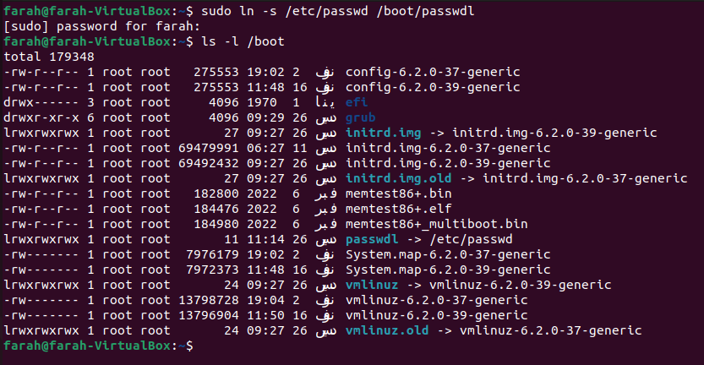

Q12:

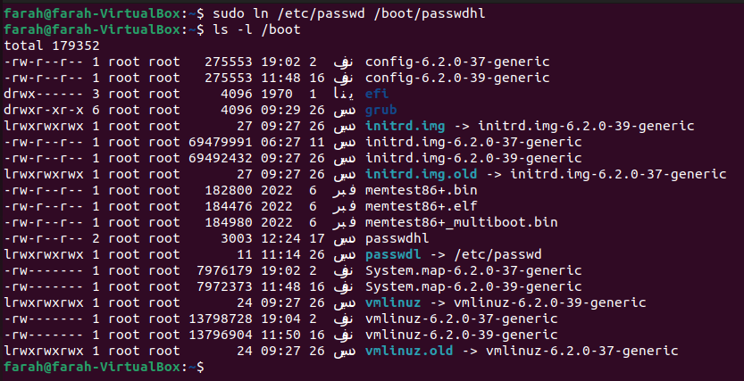

Creating a hard link of /etc/passwd in /boot is not advisable and, in most cases, not possible. Hard links cannot span across different filesystems, and /etc and /boot are often on different filesystems.

This would create a hard link named passwd_hardlink in the /boot directory pointing to the same inode as /etc/passwd.

The reason why creating a hard link is not recommended in this context is that /etc/passwd is a critical system file, and altering its links can lead to unexpected behavior or system instability. Additionally, many systems have security mechanisms in place that prevent changes to important system files.